**Geochemical characteristics and industrial appraisal of kaolin around Ajebo road, southwestern Nigeria**

Olisa, O.G. 1*, Ogunleye, S.O. 1 Omotoso, D.A. 1 and Mustapha-Aminu, S.O.2

1Department of Earth Sciences, Olabisi Onabanjo University, Ago-Iwoye;

2Department of Geology and Mineral Sciences, Kwara State University, Malete, Nigeria

*Corresponding author: [olusegun.olisa@oouagoiwoye.edu.ng](mailto:olusegun.olisa@oouagoiwoye.edu.ng), [segolisa@yahoo.com](mailto:segolisa@yahoo.com)

**Abstract**

Varieties of clays have been reported to be applicable in different industries depending on their physical, mineralogical and chemical composition. This aim of this research was to evaluate the potential uses of kaolin around Ajebo area of southwestern Nigeria. Characterization was carried out using geotechnical analysis, X-ray Diffraction (XRD), and X-ray Fluorescence (XRF). Grain size analysis revealed 77.6% – 94% silt and clay content while linear shrinkage, liquid limit, plastic limit and plasticity index ranged 8.6 - 11.4, 52 - 71, 23 - 33, and 23 – 38, respectively. Sand-silt-clay ternary plot analysis indicated low porosity and permeability, with medium to high plasticity suggesting some samples have properties suitable for industrial applications. XRD identified kaolinite and quartz as primary components, with minor amounts of mica, anatase, feldspar, clinopyroxene, and hematite. XRF results showed SiO2, Al2O3, and Fe2O3 concentrations ranged 46.93% to 56.7%, 28.46% to 35.74%, and 0.44% to 3.72%, respectively, with other oxides present in low concentrations. Geochemical indices of alteration suggest that the kaolin was formed under varying degrees of weathering. An industrial appraisal revealed the kaolin could be suitable for certain industrial processes, although some processing may be necessary to eliminate certain impurities and upgrade the kaolin percentage. However, for applications in cosmetics and pharmaceuticals, the kaolin content in the samples are below the required composition, and the concentration of trace elements shows that while some elements are within acceptable limits, the samples do not comply with the permissible lead levels for topical and oral toxicity.

Keywords: Ajebo, Kaolin, Industrial application, Toxicity, Weathering

**Introduction**

Kaolin is an essential raw material with broad industrial applications, such as water treatment; production of ceramics, bricks, paper, paints, pharmaceuticals, plastics, cosmetics and constructions (Heckroodt 1991; Murray 1991; Murray 2000; Manju 2002; Siddiqui et al. 2005; Murray 2006; Matike et al. 2011; Obaje et al. 2013; Tassongwa et al. 2014; Schroeder and Erickson 2014). It is a hydrated aluminium silicate utilized in various industrial applications to manufacture variety of products with significant commercial value. The mineralogical and geochemical compositions of kaolin have a direct impact on their physical and physicochemical characteristics (Cravero et al. 1997). Furthermore, the industrial uses of kaolin are directly related to its genesis, clay fraction and iron content (Ekosse 2001; Okunlola 2005; Okunlola and Egbulem 2015; Olisa et al. 2022; Olisa et al. 2023).

The composition and characteristics of kaolin differ significantly across various deposits, and its potential applications are affected by aspects such as its chemical makeup (the concentration of Al, Si and iron oxide as well as its color index) (Kuscu and Yildiz 2016). The ultimate use of kaolin is dictated by its physical, mineralogical and chemical properties many of which are dependent on its origin and formation environment (Murray 2005).

Kaolin is a layered silicate mineral composed of a silicate sheet (Si2O5) bonded to an aluminium oxide/hydroxide layer Al2(OH)4 known as a gibbsite layer, and repeating layers of the mineral are hydrogen bonded to one another with tetrahedral and octahedral sheets of the mineral are linked by oxygen atoms (Bish 1993; Wu 2001).

According to Brindley (1951), the kaolin group is made up of four minerals: kaolinite (Al2Si2O5(OH)4), halloysite (Al4Si4O10(OH)8.8H2O), nacrite (Al2Si2O5(OH)4), and dickite (Al2Si2O3(OH)4). Along with dickite, nacrite and halloysite, these different minerals differ based on the manner of stacking and the number of unit layers (Murray 2007; Vaculikova et al. 2011). The most common of these minerals is kaolinite, which can form over a wide range of temperatures as a result of diagenesis, hydrothermal alteration, weathering, and other processes (Schroeder and Hayes, 1968).

Kaolin physically exhibits a tint of white or nearly white with a dull or earthy texture and associated impurities may include quartz, mica, anatase, calcite, feldspar, graphite, illite, ilmenite, bauxite, zircon, kyanite, heamatite, sillimanite (Jamo and Abdu 2014; Ramaswamy and Raghavan 2011). Kaolin occurs in commercial quantity within most sedimentary basins as a product of weathering or hydrothermal alteration of rocks containing aluminosilicate minerals (Oyebamiji et al. 2017). Due to its physical and chemical characteristics, crystal structure, and surface chemistry, it is perhaps the most prevalent kaolin mineral with the most adaptable and extensive commercial applications (Prasad et al. 1991).

Minerals associated with kaolin affects its potential industrial application. For example, the Fe content stemming from the presence of iron bearing minerals such as goethite and hematite reduces its whiteness (Bertolino et al. 2010). The degree of crystallinity or weathering, which is a result of the origin of the parent components of the material also affects the qualities of kaolin (Murray and Kogel 2005). Thus, the industrial applicability of kaolin depends on its mineralogical and geochemical characteristics.

Unique industrial applications include its ability to act as a suitable medium for moulding mixture in cast iron and steel foundry, insulator refractories where the most important properties are plasticity, strength and fired colour (Oyebamiji et al. 2017). A technological classification of kaolinitic clays according to their possible application distinguishes between ball clays, brick clays, fire or refractory clays, flint clays, bloating clays and underclays ball clays and dark-firing clays (Dondi et al. 2019).

The study area extends from latitude 7°08'24"N and 7°08'27"N to longitude 3°26'7"E and 3°26'12"E. It is located in the basement complex of southwestern Nigeria, which is composed of older sedimentary rocks from the Tertiary and secondary periods as well as Younger and Older granites. According to Rahman (1988), it is underlain by crystalline basement rocks known as Older Granites. This study was carried out to determine the mineralogy and geochemical characteristics and possible industrial application of kaolin from Ajebo, Abeokuta area, southwestern Nigeria.

**Methodology**

Reconnaissance survey was carried out to locate kaolin deposit within the Ajebo area and samples taken from different layers. Nine representative samples were subjected to different geotechnical tests to determine the natural moisture content, grain-size distribution, consistency limits test, linear shrinkage and specific gravity at the Engineering Geology laboratory, University of Ibadan, Nigeria. For mineralogical analysis, samples were dried and milled to 10µm and mineralogical analysis was carried out at the Department of Geosciences University of Free State, South Africa using Panalytical EmyreanXRD.

For major oxide analysis, samples were dried and disaggregated with the aid of a mortar and pestle; and sieved to remove desired fractions for geochemical analysis. This analysis was conducted using X-Ray Fluorescence (XRF) at the Department of Geoscience, University of Free State, South Africa, employing a WD-XRF Rigaku-Primus IV equipped with a Rhodium tube. All oxides were analyzed in a fused bead format, while sodium oxide (Na2O) was analyzed using a pressed pellet method. The loss on ignition was determined by heating the powdered samples to 1050°C. The. Trace elemental composition was determined by digesting a prepared sample (0.25g) with perchloric, nitric and hydrofluoric acids. The residue was leached with dilute hydrochloric acid and diluted to volume and analyzed by Inductively Coupled Plasma-Mass Spectrometry (ICP-MS). Standards reference materials and duplicate samples were used to ensure the reliability of the data. The pulp standards and reference materials used were: S64, REP S64 and STD OREAS254A. Trace element analysis was carried out at ALS Geochemistry, Canada.

**Results**

**Geotechnical characteristics**

Geotechnical analysis results revealed that the specific gravity of the samples range from 2.270-2.578g/cm³; particle size as deduced from hydrometer/grain size analysis revealed a wide variation with clay, silt and sand fraction ranging 29.42 - 53.03%, 31.58 - 65.06% and 0.20 - 22.40% (Fig 1). The natural moisture content ranged 18 - 27%, linear shrinkage ranged 8.6 - 11.4 and kaolin samples with lower clay percentage are characterized by lower linear shrinkage values of 8.6 - 9 .3 compared to kaolin samples with higher clay percentage with linear shrinkage values of 10.7 - 11.4 (Table 1). Samples with high clay percentages are characterized by values of 52 - 71, 23 - 33, and 23 - 38 for liquid limit, plastic limit and plasticity index respectively.

**Table 1:** Particle size distribution and geotechnical properties of studied samples

|  |  |  |  |  |  |  |  |  |  |
| --- | --- | --- | --- | --- | --- | --- | --- | --- | --- |
| Sample  Number | Natural  Moisture  content | Specific  Gravity  (g/cm³) | Consistency limits | | | | Grain size (%) | | |
| Liquid limit | Plastic  Limit | Linear  shrinkage | Plasticity Index | Sand | Silt | Clay |
| 1 | 27 | 2.27 | 60 | 29 | 9.3 | 30 | 6.0 | 64.58 | 29.42 |
| 2 | 19 | 2.427 | 64 | 31 | 10.7 | 33 | 0.2 | 36.63 | 63.17 |
| 3 | 25 | 2.512 | 58 | 31 | 10.7 | 27 | 5.3 | 65.06 | 29.64 |
| 4 | 25 | 2.35 | 66 | 36 | 11.4 | 30 | 0.5 | 46.47 | 53.03 |
| 5 | 25 | 2.427 | 71 | 33 | 11.4 | 38 | 0.8 | 48.31 | 50.89 |
| 6 | 26 | 2.475 | 59 | 24 | 10.7 | 35 | 6.3 | 49.38 | 44.32 |
| 7 | 24 | 2.435 | 58 | 23 | 8.6 | 34 | 7.4 | 54.36 | 38.24 |
| 8 | 18 | 2.541 | 52 | 29 | 10.7 | 23 | 13.9 | 46.37 | 40.73 |
| 9 | 22 | 2.578 | 55 | 26 | 10.7 | 29 | 22.4 | 31.58 | 46.02 |

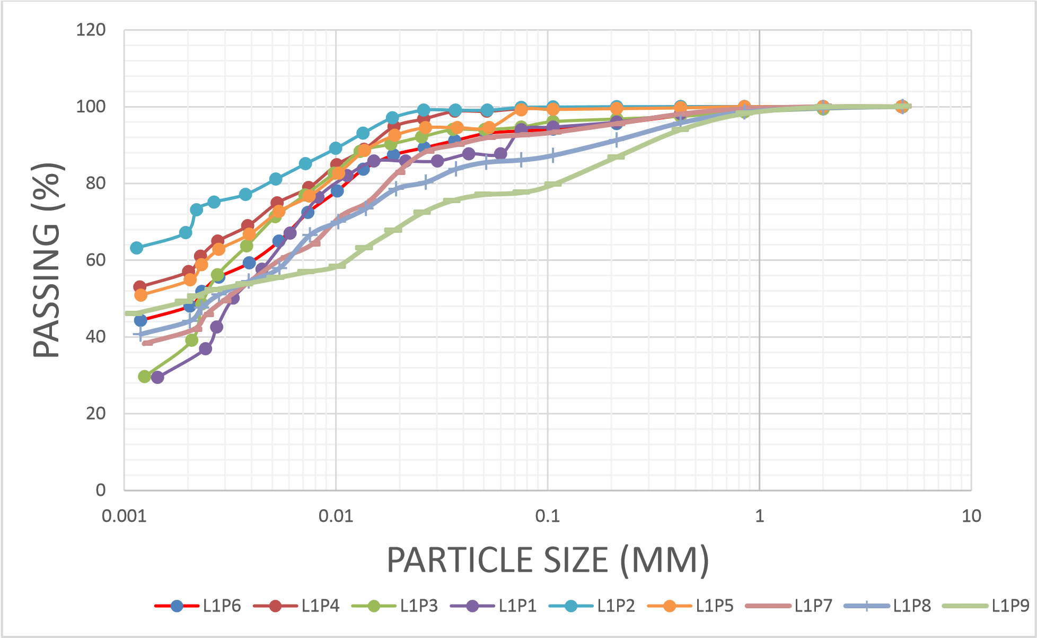

**Fig 1** Grain size analysis of kaolin from Ajebo area

**Mineralogy**

The kaolin deposit is massive having different layers with a laterite overburden of 9.2m. Overlying the deposit is intercalation of laterite and kaolin sequence reaching up to about 12m. The major minerals identified by XRD results are kaolinite and quartz; both minerals comprise over 80 wt% of the samples analyzed and accessory mica, anatase, plagioclase, clinopyroxene, and hematite (Fig 2, Table 2).

Table 2. Summary of mineralogical composition of Ajebo kaolin

|  |  |  |  |  |
| --- | --- | --- | --- | --- |
| Minerals (wt.%) | A | B | C | D |
| Quartz | 18 | 17 | 20 | 28 |
| Kaolinite | 50 | 43 | 63 | 55 |
| Mica | 20 | 12 |  |  |
| Anatase | 12 | 13 | 17 | 12 |
| Rutile/K-feldspar |  |  | 5 |  |
| Plagioclase |  | 5 |  |  |
| Clinopyroxene |  | 6 |  |  |
| Hematite |  | 4 |  |  |

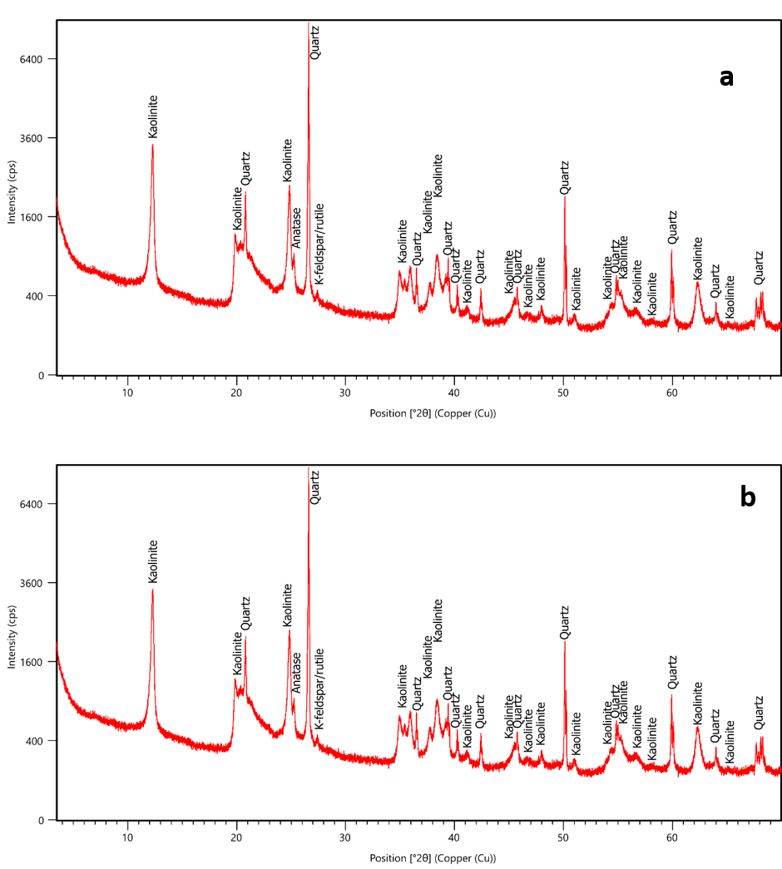

**Fig 2** X-Ray diffractogram of representative sample from Ajebo kaolin

**Geochemistry**

Chemical analysis result revealed SiO2 concentration ranged 46.93 to 56.7 wt.%, Al2O3 concentration ranged 28.46 to 35.74 wt. % and Fe2O3 concentration ranged 0.44 to 3.72 wt.%. Also the samples are significantly low in MgO, CaO, MnO, P2O5, TiO2, Na2O and K2O (Table 3).

Table 3. Elemental composition of Ajebo kaolin

|  |  |  |  |  |  |  |  |
| --- | --- | --- | --- | --- | --- | --- | --- |
| major oxide | 1 | 2 | 3 | 4 | 5 | Range | Mean |
| SiO2 | 50.85 | 46.93 | 47.02 | 49.32 | 56.7 | 46.93-56.7 | 50.16 |
| TiO2 | 1.67 | 2.01 | 1.66 | 2.51 | 2.54 | 2.01-2.54 | 2.08 |
| Al2O3 | 34.45 | 32.54 | 35.69 | 35.74 | 28.46 | 28.46-35.74 | 33.38 |
| Fe2O3 | 1.1 | 3.72 | 1.59 | 0.44 | 0.61 | 0.44-3.72 | 1.49 |
| MgO | 0.11 | 0.18 | 0.05 | 0.03 | 0.04 | 0.03-0.18 | 0.08 |
| MnO | 0.01 | 0.01 | 0.01 | 0.01 | 0.01 | 0.00-0.01 | 0.01 |
| CaO | 0.05 | 0.59 | 0.05 | 0.04 | 0.04 | 0.04-0.59 | 0.15 |
| Na2O | 0.02 | 0.01 | 0.01 | 0 | 0.01 | 0-0.02 | 0.01 |
| K2O | 0.27 | 0.31 | 0.09 | 0.04 | 0.01 | 0.01-0.31 | 0.14 |
| P2O5 | 0.08 | 0.08 | 0.03 | 0.03 | 0.04 | 0.03-0.08 | 0.05 |
| LOI | 11.89 | 11.66 | 12.79 | 11.07 | 10.17 | 10.17-12.79 | 11.52 |
|  | | | | | | |  |
| Al2O3/TiO2 | 20.63 | 16.19 | 21.5 | 14.24 | 11.2 | 11.2 – 21.50 | 16.75 |
| K2O/Al2O3 | 0.01 | 0.01 | 0 | 0 | 0 | 0.00 – 0.01 | 0.00 |
|  |  |  |  |  |  |  |  |
| CIA | 99.02 | 97.28 | 99.58 | 99.78 | 99.79 | 97.28 – 99.79 | 99.09 |
| CIW | 99.8 | 98.19 | 99.83 | 99.89 | 99.82 | 98.19 – 99.8 | 99.51 |
| PIA | 99.8 | 98.17 | 99.83 | 99.89 | 99.82 | 98.17 – 99.89 | 99.50 |
| ICV | 0.09 | 0.21 | 0.1 | 0.09 | 0.11 | 0.09 – 0.21 | 0.12 |
|  |  |  |  |  |  |  |  |
| As | 2.5 | 3.3 | 2.2 | 3.3 | 0.6 | 0.6-3.30 | 2.38 |
| Cd | 0.02 | <0.02 | <0.02 | <0.02 | 0.02 | BDL -0.03 | 0.02 |
| Ba | 120 | 60 | 20 | 30 | 220 | 20.00-220 | 90.00 |
| Cr | 117 | 90 | 121 | 129 | 110 | 90.00-129.00 | 113.40 |
| Cu | 4.5 | 8.1 | 11.8 | 14.7 | 10.4 | 4.50-14.70 | 9.90 |
| Ni | 41.7 | 47.9 | 23.3 | 27.2 | 34.5 | 23.3-47.90 | 34.92 |
| Pb | 51.1 | 21.7 | 45.9 | 64 | 46.8 | 21.70-64.00 | 45.90 |
| V | 129 | 78 | 81 | 86 | 99 | 78.00-129.00 | 94.60 |

**Discussion**

The presence of mica, plagioclase and other accessory minerals such as hematite and anatase could imply a relationship to granitic rocks and this is consistent with the geological setting of the study area.

Chemical Index of Alteration (CIA), Plagioclase Index of Alteration (PIA), Chemical Index of Weathering (CIW) and Index of Compressional Variability (ICV) are chemical indices that have been used to estimate the degree of weathering (Nesbitt and Young 1984; Fedo et al. 1995; Cox et al. 1995).

The CIA is defined as a measure of the extent to which feldspar have been converted to clays and represents a good measure of the degree of weathering. The CIW is a measure of the conversion of feldspar to clays but does not factor in the contribution of K2O (Nesbitt and Young 1982; Fiantis et al. 2010) while the ICV is a measure of the relative abundance of Al2O3.

ICV values below 50 are indicative of unweathered or weak weathering whereas values within 70-100 are indicative of intense weathering which is typified by removal of mobile alkalis relative to immobile oxides such as Al2O3  and Fe2O3 (Fedo et al. 1995). PIA is a measure of progressive alteration of feldspars to clay minerals.

$$CIA=\frac{Al2O3}{Al2O3+CaO+K2O+Na2O}×100$$

$$CIW=\frac{Al2O3}{Al2O3+CaO+Na2O}×100$$

$$ICV=\frac{CAO+K2O+Na2O+Fe2O3+MgO+MnO+TiO2}{Al2O3}×100$$

$$PIA=\frac{Al2O3-K2O}{Al2O3+CaO+Na2O-K2O}×100$$

CIA values ranged 97.28% to 99.79% in this study and fall within the range of 85 – 100% proposed for residual clays by McLennan and Taylor (1991) (Table 3). According to Baiyegunhi et al. (2017), CIA values usually range from 50% in the case of fresh rocks to 100% for completely weathered rocks. High CIA values denotes high weathering intensity, and when this value reaches 100%, Ca, Na and K concentration in the rocks have been completely leached out of the weathered residue (Nesbitt and Young 1984). CIA values in the studied kaolin are very high which indicates that they have undergone intense weathering (Table 3).

The PIA values (Table 3) suggest that there is no redistribution of K and the source rocks are not freshly weathered. According to Fedo et al. (1995), PIA values of 50% indicates freshly weathered rocks; and values close to 100%, indicates completely weathered rocks. PIA values in this study is approximately 100% which confirms the highly weathered nature of the protolith.

According to Cox et al. (1995), ICV values are higher in highly weathered minerals but low in stable minerals that less weathered. It also decreases in the montmorillite group of clay minerals and tends to be very low (less than 1.0) in the kaolinite group of minerals. ICV values for kaolin deposits in this study ranged from 0.09 to 0.21, which suggests the kaolin deposits in the study areas are compositionally mature.

CIW can provide detailed information about the intensity of chemical weathering source rocks (Fedo et al. 1995). CIW values varies from 98.19% to 99.89% and this indicates strong and intense chemical weathering (Table). The CIW vs CIA plots also shows that all the samples are extremely weathered (Fig 3a). Likewise, ternary diagram of Al2O3 - CaO + Na2O - K2O revealed a high degree of chemical alteration (Fig 3b).

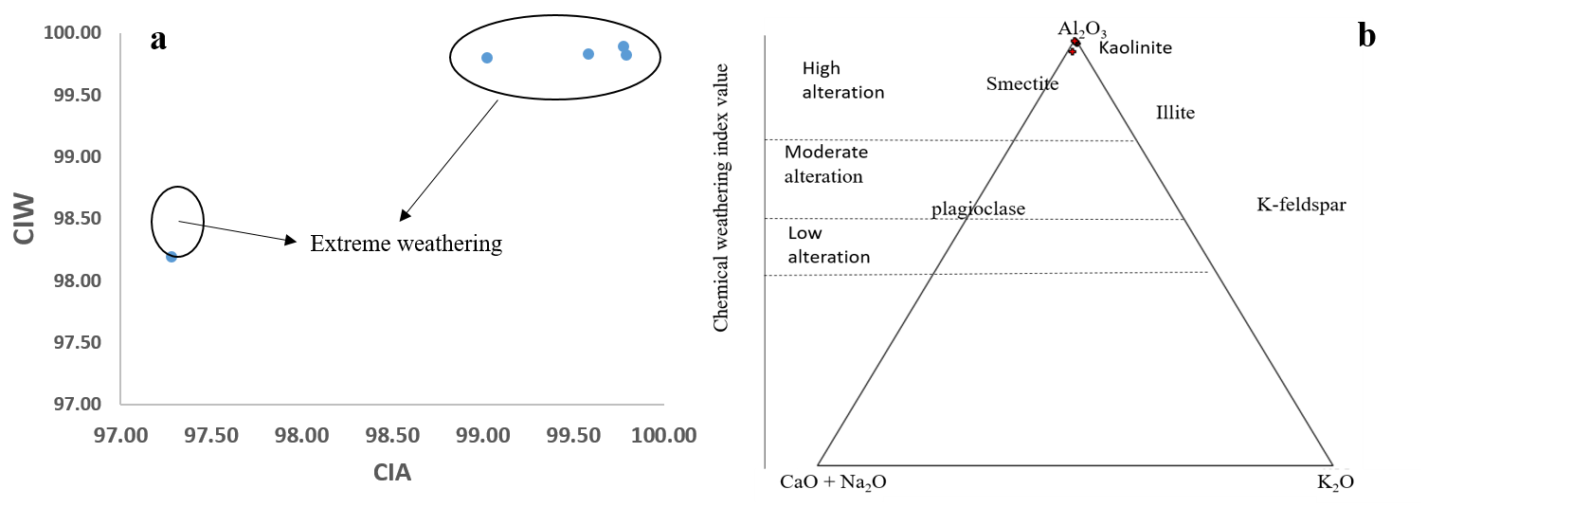

**Fig 3** (a) Plot of Chemical Index of Weathering (CIW) vs Chemical Index of Alteration (CIA); (b) Ternary diagram of CaO + Na2O – K2O - Al2O3 showing the Ajebo kaolin (Nesbitt and Young, 1984)

**Industrial appraisal**

The geochemical, physical and geotechnical properties of industrial minerals are of great importance when evaluating their scope of application for various industries (Olisa et al. 2022; Olisa et al. 2023). The industrial uses of kaolin are also determined by its mineralogy and geotechnical properties so industrial appraisal was carried out by comparison to industrial specification and appropriate geotechnical plots (Tables 4 - 5, Fig 1 and 4). SiO2 concentration in the samples falls within the specification required for use in industries such as ceramics, refractory, agriculture, textile, paints, paper coating, paper filling, plastics, fertilizers, pharmaceuticals and cosmetics. TiO2 concentration overlaps with the required specification and this will affect its industrial application except for textiles, paper filling, pharmaceuticals and cosmetics (Table 4). For other industrial applications, further processing will have to be carried out to remove excess TiO2 using appropriate dispersing agents to produce maximum deflocculation of the kaolinite particles (Maynard et al. 1969).

Al2O3 composition in the kaolin reveals that some samples meet the specification for use as refractories, paper coating, and paper filling industry while other samples meet up with the requirements of pharmaceuticals and cosmetics and refractory industry (Table 4). High Fe2O3 concentration was observed in the samples and this also reflected in the brownish to reddish color of some samples and the mineralogical and brownish to reddish color index of some of the kaolin samples. High Fe2O3 concentration in the studied samples reduces their possible industrial application although the concentration can be reduced using appropriate beneficiation methods and bleaching or through by reduction to increase the purity of the kaolin (Zegeye et al. 2013).

Table 4. Geochemical composition of studied kaolin as compared to some industrial specifications.

|  |  |  |  |  |  |  |  |  |  |  |  |
| --- | --- | --- | --- | --- | --- | --- | --- | --- | --- | --- | --- |
| major element | This study | A | B | C | D | E | F | G | H | I | J |
| SiO2 | 46.93-56.7 | 67.5 | 51.7 | 49.88 | 45 | 47.90-48.30 | 45.00-47.00 | 46.00-48.00 | 45.78 | 46.07 | 44.50-45.44 |
| TiO2 | 2.01-2.54 | - | - | 0.9 | 1.7 | - | 0.50-1.30 | 0.40-1.50 | - | 0.5 | 0.00-1.40 |
| Al2O3 | 28.46-35.74 | 26.5 | 25.00-44.00 | 37.65 | 38.1 | 37.90-38.40 | 37.00-38.00 | 37.00-38.00 | 36.46 | 38.07 | 38.10-39.50 |
| Fe2O3 | 0.44-3.72 | 0.50-1.20 | 0.50-1.20 | 0.88 | 0.6 | 13.40-13.80 | 0.50-1.00 | 0.50-1.00 | 0.28 | 0.33 | 0.10-0.20 |
| MgO | 0.03-0.18 | 0.10-0.90 | 0.20-0.70 | 0.13 | - | 0.2-0.3 | - | - | 0.04 | 0.01 | 0.10-0.20 |
| MnO | 0.00-0.01 | - | - | - | - | - | - | - | - | - | - |
| CaO | 0.04-0.59 | 0.18-0.30 | 0.10-0.20 | 0.03 | - | 0.03-0.25 | - | - | 0.5 | 0.38 | 0.10-0.20 |
| Na2O | 0-0.02 | 1.20-1.50 | 0.80-3.50 | 0.21 | - | 0.1-0.4 | - | 0.25 | 0.00-0.10 | - | 0.14 |
| K2O | 0.01-0.31 | 1.10-3.00 | - | 0.12 | - | 1.10-3.10 | 0.50-1.50 | 0.50-1.50 | 0.25 | 0.43 | 0.00-0.20 |
| P2O5 | 0.03-0.08 | - | - | - | - | 0 |  |  |  |  |  |

A= ceramics (Singer and Sonja 1971)

B = refractory (Parker 1967)

C= agriculture (Huber 1985)

D= textile (NAFCON 1985)

E= paints (Payne 1961)

F= paper coating (Prasad 1991)

G= paper filling (Prasad 1991)

H= plastics (Frados 1965)

I= fertilizer (NAFCON 1985)

J= pharmaceuticals and cosmetics (Todd 1973)

The low concentration of MgO and MnO in the studied samples meets specification for all industrial applications while the CaO and Na2O concentration of the studied kaolin makes them very suitable for paint production but the low CaO concentration affects its suitability for use in other industries (Salahudeen and Mukthar 2021).

For clays, the plasticity, moisture content, porosity and permeability depends on the particle size distribution as well as the ratio of clay, silt and sand size clasts in the clay sample. An assessment of the clay, silt, sand fractions which plays an important role in its porosity and permeability was carried out using the ternary diagram of McManus (1998). The studied kaolin samples plotted within the low porosity and low permeability field (Fig 4a) and this indicates low cohesion in the kaolin. This property makes kaolin suitable for applications such as papermaking, where it is used as a filler to improve the paper’s surface and strength. The low porosity and permeability also implies it has a low rate of water absorption which is important in ceramics industries.

The clay, silt, sand ratio determines the plasticity of the clays and higher proportion of clay and silt fractions will lead to higher plasticity while lower fractions will lead to low plasticity or no plastic clays (Daoudi et al. 2014). Based on plasticity index value, the swelling potential can be determined and moderate values will indicate a high potential for swelling while high values could indicate possibility of excessive shrinking. According to Abajo (2000) and Vieira et al. (2008), kaolin with plasticity index below 10% are not suitable for production of ceramics. The plasticity index values for the studied kaolin are above this benchmark and this implies they can be used in the production of structural clay products. However, based on the Casagrande chart (Fig 4b and c), the kaolin samples mostly plot outside the optimum/acceptable region hence they are not suitable for use in potteries and production of bricks based on geotechnical properties.

Table 5. Comparison of the mineralogical composition of the studied kaolin with some industrial applications

|  |  |  |  |  |  |  |  |
| --- | --- | --- | --- | --- | --- | --- | --- |
| Minerals | 1 | 2 | 3 | 4 | Paper filler | Paper coating | Fertilizer |
| Kaolinite | 50 | 43 | 63 | 55 | 90.00-95.00 | 93.00-99.00 | 85.00 |
| Mica | 20 | 12 | - | - | 5.00-10.00 | 7.00-10.00 | - |
| Quartz | 18 | 17 | 20 | 28 | - | - | 4.00 |
| Anatase | 12 | 13 | 17 | 12 | - | - | 3.00 |
| Hematite | - | 4 | - |  | - | - | - |
| Plagioclase | - | 5 | - |  | - | - | 3.00 |
| clinopyroxene | - | 6 | - |  | - | - | - |

Paper coating and paper filling (Prasad, 1991), Fertilizer (NAFCON, 1985).

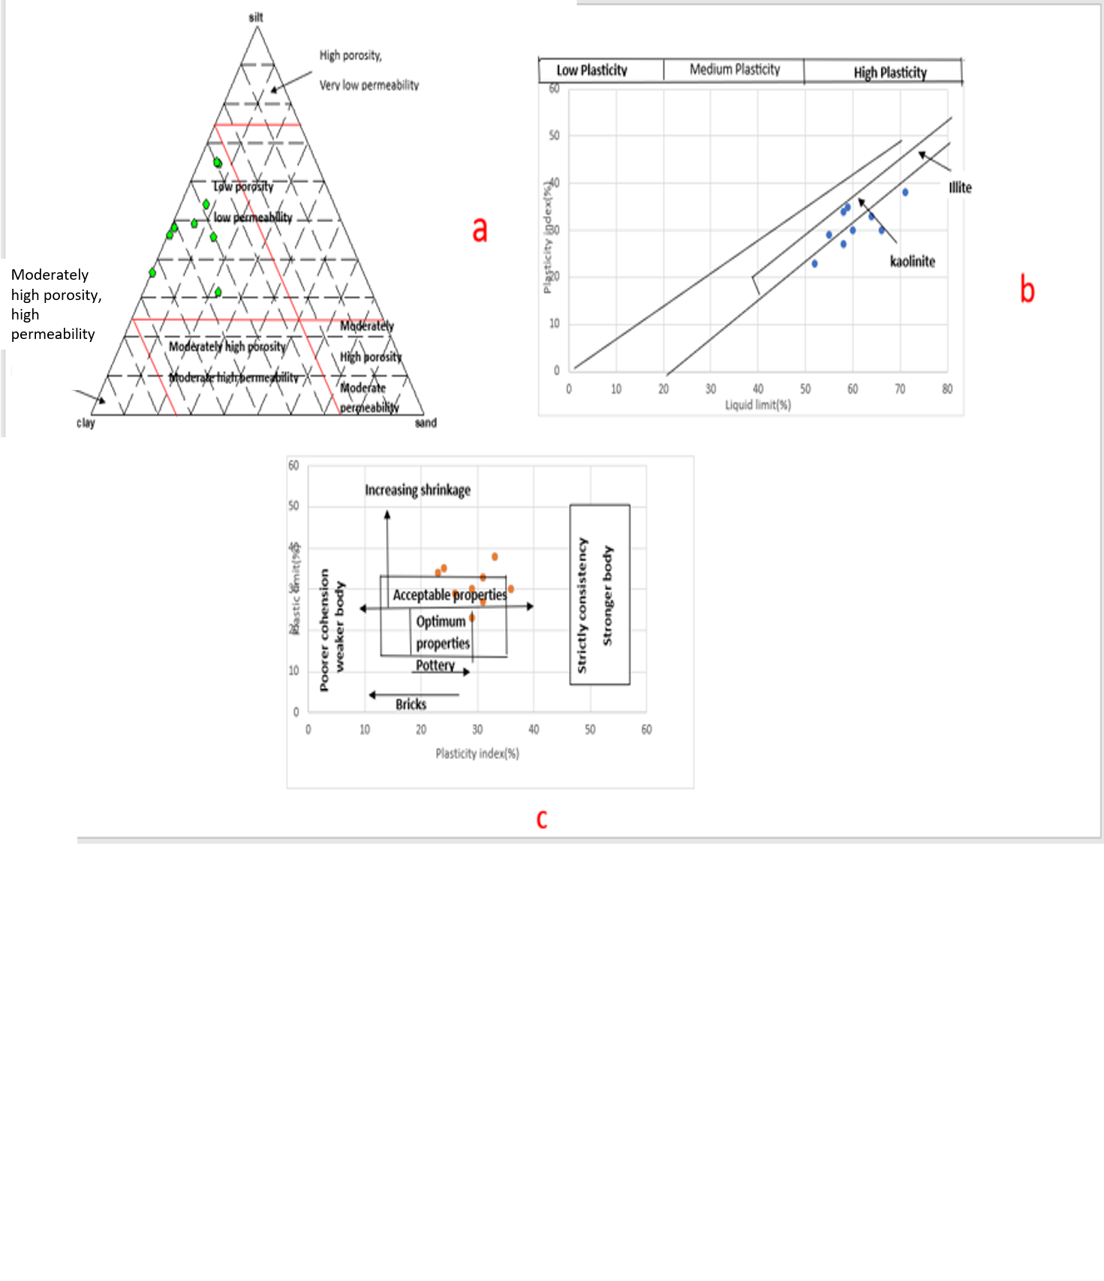

**Fig 4** (a) Ternary diagram of studied kaolins based on their sand, silt, clay fraction percentages (Fields after McManus 1998), (b) Position of the studied kaolin samples on the Holtz et al (1981) diagram, (c) Clay workability chart (after Casagrande 1948)

In general, percentage kaolinite based on XRD data ranged 43-63% and none of the samples contain over 75% kalonite which according to Kogel et al. (2006) is the grade classification for kaolinitic rocks. Based on mineralogical proportions, these samples do not show composition similar to reference kaolin commercial samples. All samples also contain anatase while a sample contains low proportion of hematite. These mineralogical impurities may be removed by chemical/physical means such as leaching, magnetic separation or floatation to improve the color and quality of the kaolin (Maynard et al. 1968; Lu et al. 2017; Larroyd et al. 2002)

Quartz is present in all samples (17-28%) as impurity and this will affect their use for mot applications especially pharmaceutical applications due to the effect of quartz ingestion as quartz use has to be avoided in the pharmaceutical industry (Olatunji et al. 2014; López-Galindo et al. 2007). The low K2O concentration of 0.01 to 0.31% is supported by the concentration of mica observed in the XRD results while higher SiO2 content of one of the sample coupled with lower Al2O3 content compared to other samples is due to the presence of quartz detected by the XRD. The high TiO2 values in the samples are also explained by the 12 to 17% mineralogical content as revealed by the XRD or substitution of Ti for Al in kaolinite (Jepson and Rowse 1975).

The higher Fe2O3 content of sample 2 can be explained by the presence of hematite. While low CaO content is supported by the absence of smectite and carbonates on the diffractograms (Kogel et al. 2006; Bleam 2017). Loss On Ignition (LOI) ranged 10.17 to 12.79% for the samples and these values < 15% which is the expected value of LOI for kaolin in pharmaceutical applications (USP 42-NF37, 2018).

Elemental and mineralogical composition directly affects the use of clays in cosmetics (da Silva Favero et al. 2019). Carretero and Pozo (2010) explained that clays with high Si content should be used in skin tissue reconstruction, mitigating against skin inflammation and providing tissue hydration. The presence and proportion of Al in clays is important for cosmetic due to its melanin adsorption, pigment dispersion, hydration and healing activity (da Silva Favero et al. 2019). The Si and Al composition in the studied clays are high as evident by the SiO2 and Al2O3 composition and this indicates the kaolin may be used in cosmetic applications.

The trace elemental concentration of kaolin also affects its use in the pharmaceutical and cosmetics industry due to their possible toxicity of the elements (Hernández et al. 2019). For pharmaceutical applications, elements such as Cd, As and Pb which are classified as Class1 according to USP 42 (2018) are required to be absent due to their documented toxicity and environmental hazards; Class 2 elements such as V, Co and Ni are of lower toxicity than Class 1 elements and their concentration are expected to be limited while elements such as Cr, Ba and Cu which are considered as risk for parenteral and inhalation routes are classified as Class 3 as they show no oral toxicity (Hernández et al. 2019).

Values of 25ppm and 50ppm are the maximum permissible Pb concentration for kaolin for oral and topical use respectively. In the kaolin studied, only one sample fails to meet the pharmacopeial requirements for topical use while only one sample meets the appropriate toxicity for oral use. The As concentration in the samples vary from 2.2 to 3.3ppm, with only one sample revealing concentration above the benchmark of 3ppm for topical application. Concentration of other trace elements considered based on their toxicity levels revealed the fall within acceptable limits.

**Conclusion**

The kaolin was studied with the aim of determining its mineralogical, geochemical characterization and possible industrial applications. Results revealed kaolinite as the dominant mineral while mica and quartz were minor minerals while trace amounts of anatase, hematite, plagioclase and clinopyroxene were observed. SiO2, and Al2O3 as the dominant oxides while oxides such as MgO, MnO, CaO, K2O, Na2O and P2O5 were present in low proportion. Comparing with required standards in various industries, the kaolin is of high economic importance because it meets up with the specifications for several industries. Based on plasticity index and particle size, the kaolin samples can be applicable in production of ceramics, pottery, paper filling, fertilizer, paper coating and paints, refractory, textile but the use in pharmaceuticals and cosmetics will be affected by the trace elemental composition..

**References**

Armstrong-Altrin, JS, Lee YI, Verma SP, Ramasamy S (2004) Geochemistry of sandstones from the Upper Miocene Kudankulam Formation, southern India: implications for provenance, weathering, and tectonic setting. Journal of sedimentary Research, 74(2), 285-297.

Baiyegunhi C, Liu K, Gwavava O (2017) Diagenesis and reservoir properties of the Permian Ecca Group sandstones and mudrocks in the Eastern Cape Province, South Africa. Minerals, 7(6), 88.

Bertolino LC, Rossi AM, Scorzelli RB, Torem ML (2010) Influence of iron on kaolin whiteness: An electron paramagnetic resonance study. Applied Clay Science, 49(3), 170-175.

Bish DL (1993) Rietveld refinement of the kaolinite structure at 1.5 K. Clays and Clay Minerals, 41(6), 738-744.

Bleam W (2017) Clay Mineralogy and Chemistry. In: Soil and Environmental Chemistry pp. 97–146, Academic Press. <https://doi.org/10.1016/B978-0-12-804178-9.00003-3>

Brindley GW (1952) Identification of clay minerals by X-ray diffraction analysis. Clays and Clay Minerals, 1, 119-129.

Carretero MI, Pozo M (2010) Clay and non-clay minerals in the pharmaceutical and cosmetic industries Part II. Active ingredients. Applied Clay Science, 47(3-4), 171-181.

Casagrande A (1948) Classification and identification of soils. Transactions of the American Society of Civil Engineers, 113(1), 901-930.

Cox R, Lowe DR, Cullers RL (1995) The influence of sediment recycling and basement composition on evolution of mudrock chemistry in the southwestern United States. Geochimica et Cosmochimica Acta, 59(14), 2919-2940.

Cravero F, Gonzalez I, Galan E, Dominguez E (1997) Geology, mineralogy, origin and possible applications of some Argentinian kaolins in the Neuquen basin. Applied Clay Science, 12(1-2), 27-42.

da Silva Favero J, dos Santos V, Weiss-Angeli V, Gomes LB, Veras DG, Dani, N, et al (2019) Evaluation and characterization of Melo Bentonite clay for cosmetic applications. Applied Clay Science, 175, 40-46.

Daoudi L, Knidiri A, El Idrissi HEB, Rhouta B, Fagel N (2015) Role of the texture of fibrous clay minerals in the plasticity behavior of host materials (Plateau du Kik, Western High Atlas, Morocco). Applied Clay Science, 118, 283-289.

Dondi M, Gian Paolo B (2022) Basic guidelines for prospecting and technological assessment of clays for the ceramic industry. Part 2. Interceram-International Ceramic Review, 71(1), 28-37.

Ekosse G (2001) Provenance of the Kgwakgwe kaolin deposit in Southeastern Botswana and its possible utilization. Applied Clay Science, 20(3), 137-152.

Fedo CM, Nesbitt WH, Young GM (1995) Unraveling the effects of potassium metasomatism in sedimentary rocks and paleosols, with implications for paleoweathering conditions and provenance. Geology, 23(10), 921-924.

Fiantis D, Nelson M, Shamshuddin J, Goh TB, van Ranst E (2010) Determination of the geochemical weathering indices and trace elements content of new volcanic ash deposits from Mt. Talang (West Sumatra) Indonesia. Eurasian Soil Science, 43, 1477-1485.

Heckroodt RO (1991) Clay and clay materials in South Africa. Journal of the Southern African Institute of Mining and Metallurgy, 91(10), 343-363.

Hernández AC, Sánchez-Espejo R, Meléndez W, González G, López-Galindo A., and Visceras C (2019) Characterization of Venezuelan kaolins as health care ingredients. Applied Clay Science, 175, 30-39.

Viseras C (2019) Characterization of Venezuelan kaolins as health care ingredients. Applied Clay Science, 175, 30-39.

Holtz RD, Kovacs WD, Sheahan TC (1981) An introduction to geotechnical engineering (Vol. 733). Englewood Cliffs, NJ: Prentice-hall.

Jamo HU, Abdu SG (2014) Structural analysis and surface morphology kaolin. Science World Journal, 9(3), 29–30.

Jepson WB, Rowse JB (1975) The composition of kaolinite—an electron microscope microprobe study. Clays and Clay Minerals, 23, 310-317.

Kuşcu M, Yıldız A (2016) The mineralogy, geochemistry, and suitability for ceramic applications of Akharım (Afyonkarahisar, W Turkey) kaolinitic clay. Arabian Journal of Geosciences, 9, 1-17.

Larroyd F, Petter CO, Sampaio CH (2002) Purification of north Brazilian kaolin by selective flocculation. Minerals engineering, 15(12), 1191-1192.

López-Galindo A, Viseras C, Cerezo P (2007) Compositional, technical and safety specifications of clays to be used as pharmaceutical and cosmetic products. Applied clay science, 36(1-3), 51-63.

Lu M, Xia G, Cao W (2017) Iron removal from kaolin using thiourea dioxide: Effect of ball grinding and mechanism analysis. Applied Clay Science, 143, 354-361.

Manju CS (2002) Mineralogical, morphological and geochemical studies on Kundara and Madayi kaolins, Kerala. Doctoral dissertation, Regional Research Laboratory CSIR.

Matike DME, Ekosse GIE, Ngole VM (2011) Physico-chemical properties of clayey soils used traditionally for cosmetics in Eastern Cape, South Africa. International Journal of the Physical Sciences, 6(33), 7557-7566.

Maynard JB (1975) Kinetics of silica sorption by kaolinite with application to seawater chemistry. American Journal of Science, 275(9), 1028-1048.

McLennan SM, Taylor SR (1991) Sedimentary rocks and crustal evolution: tectonic setting and secular trends. The Journal of geology, 99(1), 1-21.

Murray HH (1991) Overview—clay mineral applications. Applied clay science, 5(5-6), 379-395.

Murray HH (2000) Traditional and new applications for kaolin, smectite, and palygorskite: a general overview. Applied clay science, 17(5-6), 207-221.

Murray HH (2006) Applied clay mineralogy: occurrences, processing and applications of kaolins, bentonites, palygorskitesepiolite, and common clays. Elsevier.

Murray HH, Kogel JE (2005) Engineered clay products for the paper industry. Applied Clay Science, 29(3-4), 199-206.

Murray HH, Alves CA, Bastos CH (2007) Mining, processing and applications of the Capim Basin kaolin, Brazil. Clay Minerals, 42(2), 145-151.

National fertilizers company of Nigeria (NAFCON)(1985) Tender document for the supply of kaolin from Nigeria sources.

Nesbitt HW, Young GM (1984) Prediction of some weathering trends of plutonic and volcanic rocks based on thermodynamic and kinetic considerations. Geochimica et cosmochimica acta, 48(7), 1523-1534.

Obaje SO, Omada JI, Dambatta UA (2013) Clays and their industrial applications: Synoptic Review. International Journal of Science and Technology, 3(5), 264-270.

Okunlola OA (2005) Compositional characteristics and functional industrial application of Itakpe clay occurrence central Nigeria. Editorial Advisory Board e, 453.

Okunlola OA, Egbulem C (2015) Geological setting, compositional and economic appraisal of clay-shale occurrence in Itu-Mbonuso/Iwere Area, South-Eastern Nigeria. Journal of Geography and Geology, 7(1), 85-96.

Olatunji AS, Olajide-Kayode JO, Abimbola AF (2014) Evaluation of geochemical characteristics and health effects of some geophagic clays southern Nigeria. Environmental geochemistry and health, 36, 1105-1114.

Olisa OG, Ajibade OM, Ogunjinrin OA, Ayodele M, Bamgboye DO (2022) Preliminary mineralogical and geotechnical characterization of kaolin from Abeokuta area, southwestern Nigeria. Scientia Africana, 21(2), 97-104.

Olisa OG, Ajibade OM, Welman-Purchase MD, Ogunjinrin OA, Bamgboye DO, Ayodele MO (2024) Mineralogy, Geochemistry and Industrial Appraisal of Kaolin from Abeokuta Area, Southwestern Nigeria. Journal of the Geological Society of India, 100(5), 745-754.

Prasad MS, Reid KJ, Murray HH (1991) Kaolin: processing, properties and applications. Applied clay science, 6(2), 87-119.

Rahaman MA 1988 Recent Advances in the Study of the Basement Complex of Nigeria. Symposium on the Geology of Nigeria, Obafemi Awolowo University

Ramaswamy S, Raghavan P (2011) Significance of impurity mineral identification in the value addition of kaolin–A case study with reference to an acidic kaolin from India. Journal of Minerals and Materials Characterization and Engineering, 10(11), 1007.

Salahudeen N, Mukhtar AA (2021) Effect of beneficiation on the characterization of getso kaolin. Mining Revue, 27(4), 72-77.

Schroeder PA, Erickson G (2014) Kaolin: From ancient porcelains to nanocomposites. Elements, 10(3), 177-182.

Schroeder RJ, Hayes JB (1968) Dickite and kaolinite in Pennsylvanian limestones of southeastern Kansas. Clays and Clay Minerals, 16, 41-49.

Siddiqui MA, Ahmed Z, Saleemi AA (2005) Evaluation of Swat kaolin deposits of Pakistan for industrial uses. Applied Clay Science, 29(1), 55-72.

Singer F, Sonja SS (1971) Industrial Ceramics Publication. Chapman and Hall, London, UK, pp 18-56.

Tassongwa B, Eba F, Njoya D, Tchakounté JN, Jeudong N, Nkoumbou C, Njopwouo D (2017) Physico-chemistry and geochemistry of Balengou clay deposit (West Cameroon) with inference to an argillic hydrothermal alteration. Comptes Rendus. Géoscience, 349(5), 212-222.

Vaculikova L, Plevova E, Vallova S, Koutnik I. (2011) Characterization and differentiation of kaolinites from selected Czech deposits using infrared spectroscopy and differential thermal analysis.

Wu W (2001) Baseline studies of the clay minerals society source clays: colloid and surface phenomena. Clays and Clay Minerals, 49(5), 446-452.

Zegeye A, Yahaya S, Fialips CI, White ML, Gray ND, Manning DA (2013) Refinement of industrial kaolin by microbial removal of iron-bearing impurities. Applied Clay Science, 86, 47-53.